P234.2

#include <iostream>

using namespace std;

class student

{

char name[20];

unsigned int id;

double score;

public:

void input()

{

cout << "name? ";

cin >> name;

cout << "id?";

cin >> id;

cout << "score? ";

cin >> score;

}

void output()

{

cout << "name: " << name << "\tid: " << id << "\tscore: " << score << endl;

}

};

int main()

{

student s;

s.input();

s.output();

system("pause");

}

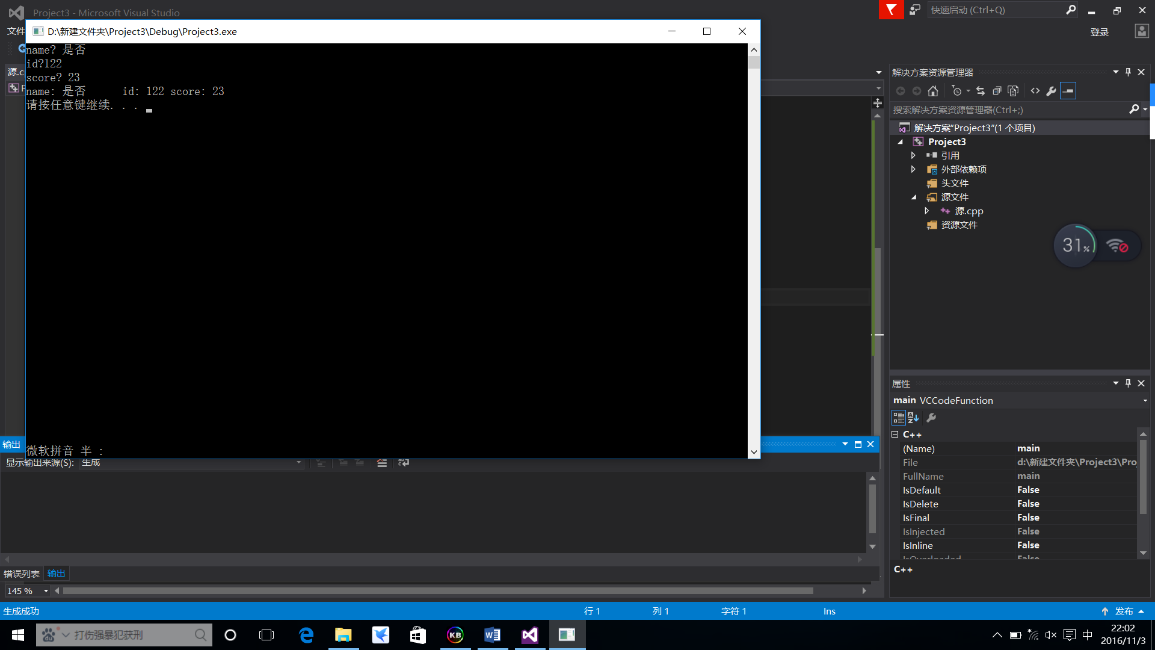

P242.1

#include <iostream>

using namespace std;

class Book

{

public:

void setBook(char*, double, int);

void borrow();

void restore();

void display();

private:

char bookname[40];

double price;

int number;

};

void Book::setBook(char *name, double pri, int num)

{

strcpy_s(bookname, name);

price = pri;

number = num;

}

void Book::borrow()

{

if (number == 0)

{

cout << "已没存书，退出！" << endl;

abort();

}

number = number - 1;

cout << "借一次，现存书量为：" << number << endl;

}

void Book::restore()

{

number = number + 1;

cout << "还一次，现存书量为：" << number << endl;

}

void Book::display()

{

cout << "存书情况：" << endl

<< "bookname:" << bookname << endl

<< "price:" << price << endl

<< "number:" << number << endl;

}

int main()

{

char flag, ch;

Book computer;

computer.setBook("新垣结衣", 32, 1000);

computer.display();

ch = 'y';

while (ch == 'y')

{

cout << "请输入借阅或归还标志(b/r)：";

cin >> flag;

switch (flag)

{

case 'b': computer.borrow(); break;

case 'r': computer.restore();

}

cout << "是否继续？(y/n)";

cin >> ch;

}

computer.display();

system("pause");

}

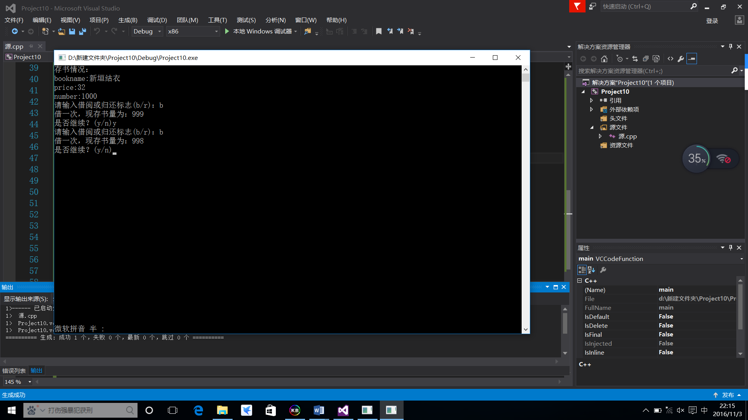

P242.2

#include <iostream>

using namespace std;

class BOX

{

public:

BOX(double l, double w, double h)

{

length = l;

width = w;

height = h;

}

void volume()

{

cout << "volume=" << length * width * height << endl;

}

private:

double length, width, height;

};

int main()

{

BOX box1(1, 3, 5);

box1.volume();

BOX box2(2, 4, 6);

box2.volume();

system("pause");

}

